# XII. mountain rose

XII. mountain rose 1

Dear All, 3

[from moleskine#6] 4

sho la la la sprish sha sha… 8

Haley, 10

the valley of shattered wildflowers 12

The Botanist’s Daughter 13

“the practice of sincerity” 14

[from moleskine #5 sept 2010] 15

“or I guess the grass is itself a child…” 17

A Compendium of Flowers and Weeds 21

hush, dear hands 25

Sappho 24 26

[ one of our stories]

[facebook announcement]





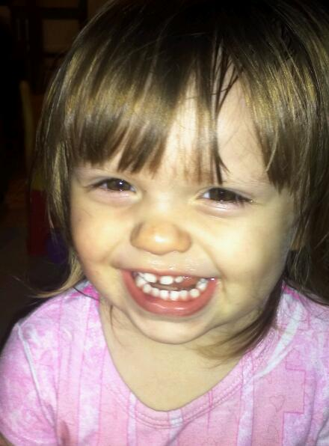

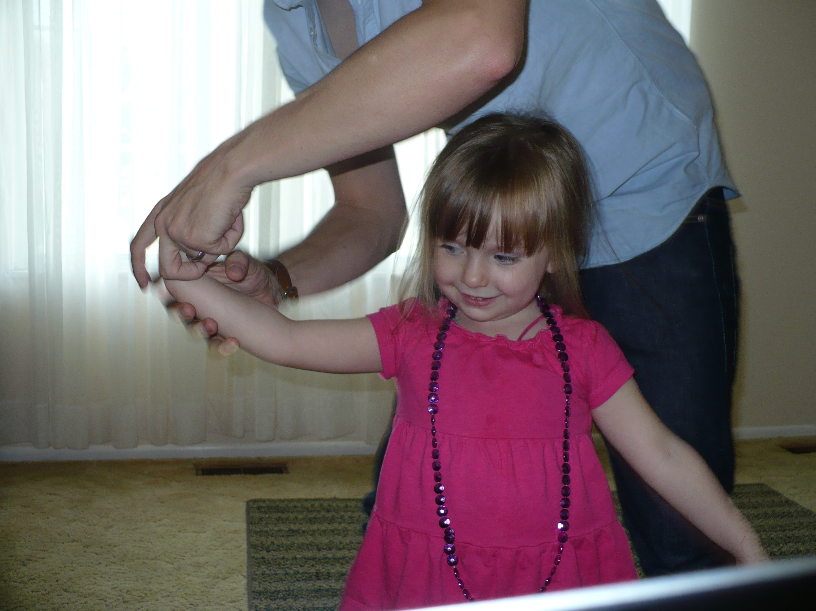

“haley”

like a mountain

rose, thick

with thorns in the rocks, bright

with thin sun-  
light: little girl your face

*ii.*

ancient manuscript version:

likeamountain

rosethick

withthornsintherocksbright

withthinsuns

lightlittlegirlyourface

## Dear All,

I had planned on being back for teaching tomorrow, but early Wednesday morning we took Haley to the emergency room with a fever, and have been here since. We should be home tomorrow afternoon, but not in time for teaching.

I will be back next week, but until then I need to give you some direction for your final paper. I have been remiss in my duties, as I know that you all eagerly burst to begin work on your papers. I am sure that you want to spend as much time as possible in diligent labor, and I would hate to be the one to stand in your way.

Below I’ve given some general guidelines and possible areas of inquiry. If these are helpful to you – fine. If not, and you would prefer to develop your own topics – all the better. The possibilities I’ve provided for you are already quite open-ended. I suggest that you read ahead to Euripides’ *Bacchae,* as it is an incredible play and provides a great deal to think about for papers. I will be available Monday, 12/3, for optional meetings.

I look forward to seeing you next week, where we will be nearing the close of our semester’s reading.

Until then,

M

*ii.*

to write life in telegraphic prose-poem style of Ginsberg poem-prefaces and cover-backs:

born awhile ago as a baby. small with tiny fingers and pink. from hospital returns with

parents to mobile home before growing up. meanwhile shy and smart wins writing prizes and school spelling bee in sixth grade. before that sister born when nine with mental retardation. moves around starts using drugs at fourteen huffing gasoline in parents’ garage taking long pink codeine pills four at a time first time i drank throwing up two days straight. at seventeen finally finding morphine and later the needle at last chained to my incredible illness. before that reading ginsberg’s howl kerouac’s on the road ayn rand’s atlas shrugged plato’s apology some of nietzsche’s thus spake zarathustra which i never finished all in the space of a year when fifteen. decides to get “integrity” tattooed across chest in old english lettering but never follows through. becoming a neo-Beat poet winning high school poetry contest first place for “you have opiate tongue when / fluttering in my mouth.”

in a hospital room now sleeping on the chair my wife with her breast out and our baby

girl having lost 9% body weight and tiny jaundice because of hunger and difficult time with breast-feeding looking forward to lack of sleep and midnight poesy made out of crazy.

*iii.*

frail pattering

fingers,

teeth: my baby

girl like

halcyon or

violets.

## [from moleskine#6]

2/6/09 7:40pm

where there

is a will there

is a way. i think.

in

private here i'm

thinking, about how

to solve the problem of

the Absolute and put

words down here

in words. how to put words

in words, accompanied

by power? if i

to you

the touch

here

of silences

that break open:

*ii.*

eyes

leak

speechless-

ness like

dreams: i'm

coming

soon

to you

my darling, soon

i'll come

to you.

but until then dreams

break open, tiny

shells w/ yolks, like

statuettes

of silence: light blue

shell like

tiny

skies. i

rise

to you my

darling. rise.

and the skies

rise too on top

of water, floating on the

atmosphere

in oceans

bright

and deep:

these motions of the

element

time, like liquid

darkness and

wine, bead:

spinning dusky and

blue, like flowers

on a stain-etched

face.

yr eyes are a winedeep blue

and stain-etched,

dear,

yr face like

snarls

of rain. there is no

tenderness so

open. for you i put

the words

here

back

in the form

of words.

if the line

is a breath and i

am the lines

that burst

across college-ruled

angles, running

parallel

to robins--then

my life lives

in the reading. my life breathes

on your lips.

*iii.*

slowly, golden city,

i will build you

with drops of blood.

Sappho 132My little girl’s face,  
like bright   
yellow flowers: Cleis,  
more precious to me  
than all Lydia.

*ii. Sappho 98b*but Cleis I don’t know  
where to get the special  
ribbons to hold  
your hair back:  
  
there’s nowhere, Cleis.  
  
just one more reminder that Myrsilus  
has exiled us  
from Mytilene.

*iii. Sappho 102*Mother I do   
love you, but I really can’t  
work the loom –   
  
Aphrodite is making me need that boy

*iv. Sappho 105b*

like the mountain hyacinth

trampled by shepherd men’s

feet,

and on the ground

the purple flower

*v. milk thistle*

my little girl’s hair

like love-burnt stalks,

like wheat-tan weeds or

dandelions bound

in a row: a braid her summer

face. or milk thistle sap

when she breaks with tears, the rag-

sewn dress her glory.

in time to come there will be no

weeds, but bodies of light and power.

remember me

little flower.

## sho la la la sprish sha sha…

mountain rose, your brittle white

edges singed

by frost. ringed by tufts of hard

dark grass. this love i have

is the love that breathes, without you i…

… arch fires, patterns of fingers, hard

white capillaries cracked

in a desert: your face

burning: shall i

set you on a pedestal or as

a star hang you with embroidery

in the midnight sky, as a setting? or see you

as you are, baby girl – which would not be much of a poem

to write. words break

shakily

on the shore – one by one they die. the sentence, then

flows over them and breathes them back

to the sea. these things break and must do so until the end of time.

Phrasewordsentencesoundsongsymphonypoemlifeblood. though i am crippled,

i walk. though deaf i hear, though dumb i speak. and though the grave has claimed me, live.

you belong to me. soften yourself to me, let me sleep. Sho la la la la, sho la la la. Sprish sha sha sha sha

singing in time

with pattern

*ii.*

with the passage

of time: your fingers

teeth and

hair;

your innocent stare.

your hair wisps surround you,

veil your face from the breeze

of hands that awkwardly

brush them

away.

dandelion. sunblossom:

death came in

to the world w/

you--you are my

life, my

death--to know

that in you i live,

and likewise you

in me; + in you

yr fragile

baby-face, yr hands yr

hair the way you fall

on yr butt:

you are my sad-

soft chain

to forever. you could

break

whenever.

## Haley,

you could never know how much you've meant to me. My heart breaks into tiny pieces with the weight of this gift God's given. You are my light song, yr halo hair like sunflowers, leaves yr brown-gold tuft of feathers--sad-precious-sweet, and the love is bittersweet, to know you'll grow. Remember your daddy. i love you so.

Haley I want you to know, more than anything else, how much your daddy loves you.

Dear Haley,

I have not been the strongest man. I have failed, and buckled, and surrendered to life. I have done the wrong thing. I have lied and deceived. I want to be a better man for you, dearheart. I want to love you with a love so full and real it surrounds you, and stays with you forever, wherever you go. I want to love you with a love so great it / clamors to you in all your silences and says to you--"i love you, i love you, i love you." i want the smell of my love to linger in your hair, + on your little purple dress so that it covers you all day long. i want to love you with a love so real, it comes to you in your dark hours, when the sting is too much, and when the lights are out and you feel like life has forgotten you, and the tiny day of your oh-so-fading life--all our lives so fleeting--and says to you, "light, comfort, a bandage. a song to fill you up, a reminder that i'm with you." life so brief, baby girl. here and gone. i will be there for you.

i never knew a love like this that could call out from the deeps, that could rattle me apart to find my deepest recesses to empty them empty them out and fill them back up with love.

is this the love God feels for us?

oh how we break his heart! oh how his heart breaks with love!

everyday we experience things that go so far beyond what we understand, our whole clothing of skin and flesh--and the deeper clothing "soul"--is filled with veils that lift, but do not reveal.

all uncovered in my deeps

and yet i can't see a thing!

what silly creatures we are, who break apart + return to dust in the space of a day. what creatures of a day who carry this impossible pearl.

some day you'll read this (i hope) and someday far from here, when you yourself have felt the whisper of night and tasted the breeze of the fading day--it might even reach you--my letter might even / read you!

*ii.*

Giovanni,

I can't imagine how hard it must be to be a stepchild. I know now from the love I've learned from Haley--a love I never knew before--how much you've been robbed by not having the love of a father--your own father--to love you with this impossible love that breaks me apart. I know I haven't loved you with the depth that a real father could. (You haven't made it easy, you know =)

But Gio I do love you and I do want to be a good dad to you, even if that's a stepdad. He puts the fatherless in families. Won't you receive that from me? Won't you receive the love I have for you, even if it's not from your father? We have a spirit of adoption in god--we can call out Abba! Father!

you are a good boy Gio, and I love you and believe in you. this poor old broken life we live--so full of hurt + disappointment--can still fill up with light--even if it's a fragile light, just a tiny / little candle in what seems, at times, to be an impossible darkness--that is our light, that is the light of our God--our God who, like no other God, lived and breathed and felt pain, was beaten and pinned to a cross, felt loss and wept and bled--our God's light is this silly light of fingers and toes that fade to dust in the space of a day--this impossible, tiny love like a mustard seed--it's like a tiny candle that swallows up all the infinite darkness.

darkness outside the circle of light,

slavering, teeth-bright stars that pierce

the neck of sky.

Our light is this light that comes in the midst of our brokenness and pain and skin and bones and the hard beginnings you've had in life, and the places you've felt hurt and pain, and the times you've been broken and wronged--even in those he's there. He loves you so much--He has never left you. He's always had his arms around you. *He* loves you with a father's love. *He* loves you with a love so bright it will swallow up your shadows--even those shadows that seem so dark and real.

remember how much he loves you, and know that i love you, too. and believe in you.

you're a good boy Gio. Love you.

-Matt

## the valley of shattered wildflowers

father, when my skin is gone, will you see me

opened up in my ugliness

and stripped of the lies that hide in flesh?

or will it be a subtle thing, a soft

voice struggling against the muffling skin

that then breaks free to honor you over

and over again?

what will you find inside me?

how is it that you know

while I don’t? that you see

inside all my layers to know the truth

that hides there? if I am evil then I

most certainly have hidden it

deep as deep as deep in the skin

and away from the sun as I

was able – and yet if I am evil you

know that truth of me and I

am ignorant

and again, if I am good I cannot

see it, covered up with all this

filth and muck, too

shot through with doubt and dust, but you--

you knew my secret heart from before

the world began, and loved me because

I loved you back – before I knew, you loved, before I loved,

you knew –

even my desire for your softness, and to rest

in the shadow of your wings, and to lay

my head on your chest, my savior, to love

you face to face, to be forgiven and finally

set free, and clean: this too could be

deceit, a lie I tell myself to hide from my own

damnation. who can know the heart? not me.

but you search the hearts and the anxious thoughts,

you search out all the darknesses, and the drawers

## The Botanist’s Daughter

“Or I guess the grass is itself is a child...”

**i.**

Sloppy blue track jacket

nylon netting lines the pockets

**ii.**

we gather dandelions in a pewter pail

streams of sand and gravel. She plants

three crumpled handfuls of stalks,

breathing life through clay,

hunched like a surgeon.

**iii.**

carpet of dandelion shooting down

to explore with shallow fingers

the history of dirt,

the etymology of gravel,

and all the individual parts of sand

drawing dull mineral granules

to radiate in its dust-gold brain

**iv.**

bedtime, girls asleep, half-heartedly shuffling through floor's

sullen clutter. upend jacket to find

flowers spilling out.

but mostly dirt

**v.**

in the crack between porch and shrub

assorted grimy weeds, chunks

of sidewalk stone, intricate

arrangements of pinecones,

void space:

little girl's zen garden

*by Haley--(transcription)*

Once upon a time, there was a Lady named Aunt Amy. She was going to walk on the stairs, and she knew why run on a treadmill she was having a baby, but she knew why that she played and

THE END

## “the practice of sincerity”

how do I see her?

Through a subtle but cloying film of guilt, knowing

all of it is passing. Out of the corner of my eye

I ignore you, while I type these twice useless

words. One set of words paves the narrow way

to a palace of words in heaven: words exchanged in

committees, words securing money, words

dumped out in lecture halls--a wall of words to brick up

a life in stupid promotions, tenure, and petty

animosities endless. And what else is there?

You, I know. But I haven’t a clue how to get there.

The other set of words is equally useless, more so

because of their beauty. They brush up against

nothing and bridge nothing and build no towers

of Babel. Just trinkets, gleaming things in the window,

things I put in my amazon basket. Is that what I’d give you,

this gift of….? This ache to push through the skein of

words?

But I don’t even have any arms I’m a

brain on ice. I interface with an invisible

keyboard digitized in my genome. It’s all I

am, these symbols, twice useless bolts of ones

and zeros, a cloth of just two colors.

I weave it together, I pick it apart, I

weave it together, I pick it apart. And so on.

Nothing that could end up

as an object, or as a three-dimensional

flower.

So you have chosen to reveal

with words, the purple-blue bruise

outbleeding, while I sit here and

cover it up, with language slightly

purple:

Little flower

remember, little flower

forget.

*iii.*

What fills up a poem

w power?

That brass heart, love, I guess, the impossible

crown of ivy,

r the cruciform rope

of roses.

If I were to eat

yr startled images

or yr bloated

surface emotion,

r the silt-heavy

tear on yr lip

r the crumb from potato

chips:

now what to do with it

when it’s empty?

## [from moleskine #5 sept 2010]

language burns away like fog--

a dream at dawn.

*ii.*

i know your face

even fogged in fingers of sleep.

*iii.*

glistening in the fingers of sleep, yr skin.

the shadows play across iris-bright eyes

*iv.*

yr face like a whisper late at night:

musky hummingbird hearts of speech.

a finger of song in sleep.

*v.*

white shards burst:

a sleepy blink

*vi.*

the very stones would sing

the earth cry out in wonder

*vii.*

the ancient rain wells up,

a drop of blood.

*viii.*

speak to me, living being.

use my voice like a body.

reach past skin and teeth

down throat to find the fingers of flesh

gripping the groin like roots,

drawing moisture from deep earth oceans.

continue thru lotus-fringed caverns

of sleep, where forgetfulness laps

along icy banks and the ancient city

echoes.

from *that* place,

draw song.

from thatplace fill

my body with longing.

a new song, come.

*ix.*

empty buildings at night--

the house of the Moon.

the voice is gone--again--

and nothing comes in its place.

not pain, not joy, not loss.

some reserve of strength

like a dandelion mane--

released

## “or I guess the grass is itself a child…”

i.

the magicians Math and Gwyddion

taking the seeds and stems

of meadowsweet, broom, and oak

fashion the bride unborn: Bloddeu-Wedd / Blossom-Face

*Vast whisp-whisp of wingbeats*

*minute-long string of black geese*

the meadowsweet (also ulmaria, fen-

meadow, brideswort): moist-

dark, born in dew

the broom (also laburnum, ulex, Cystius):

slender green stems and delicate leaves

yellow petals in stubborn clusters

bunched up close to the branch. fire-

climax species, white-knuckled on sandy

scree. unfolds its tender palms in fire,

germinates in the seasonal burns:

ashborn

the oak, or quercus:

its catkins w purple growth, the seed in its crowny

cupule, serrated leaves rising up in a spiral

elegant hanging cyllinders, testicular lavender fuzz

blood and sap, sap and blood

the blood is thin or thick

the blood is blue or red, the child

takes after her mother

all down the limbs

the flowing stains

touch the blond trunk like wine

the way the stain of blood

like a vibrant dye:

*ion, iona,* violets

bower of veins and woven

vines

violets for the blood

to care for a word, to fiercely adore it,

to send shooting love down its roots

to call it by its rightful name:

seanrog, little clover,

trifolium cloeferwort

with your small white, pale pink flowers

ii.

what kind of flowers

were the golden ones

to which Sappho compares

her Cleis?

*anthemoisiv*:

the generic word for a blossom

or the anthem, a kind of choreograph

set to song

the naturalist’s notebook:

columbine

in a lime outcropping

caught in a rift in stone

the spur of the petal whirs

like a single, tiny sparrow

anemone coronaria: anemone for its wind-

bleeding seeds, coronaria

for its circlet of blood

purpura – violet, bright,

purpureus for its murmuring dress

asphodel, like great white ashes: ghostsflowers

laid against tombs, smoke enough – like a rain of ash –

to feed the thin dead with forgetfulness

*skeleton thick sunflower, saw-*

*dust root, corolla of spikes, seeds*

*fallen out of its face*

*dress of dust and soot-blue eyes*

i’ve never paid attention to roses

or any other flowers but weeds –

like the zebra-stripe yellow of milkthistle worm (the monarch)

chewing through w bright precision

the dullcolor leaves,

w popping sap pods,

the common purple blossoms

and dandelions for the way they

carpet – the same thing that makes them

weeds. each spring a mannered pogrom

lawn ablutions of subtle poisons

before even the late dry

summer heat can change the upturned cheeks

to the puff-white manes of grandfather stalks

*This grass is very dark*

*to be from the white heads of*

*old mothers,*

*Dark to come from under the faint red roofs of mouths.*

*Or I guess the grass is itself a child. . . .*

the dandelion flotilla:

the needle-like beak lifts a tuft

of feathers, the pappus carrying fruit

the dangling Achene sheathed in spines

ribbon-like corolla of petals, golden,

inside, the stigma catches seed. a cylinder of

woven anthers. the fragrant flowerhead

above a hollow stem. bitter white juice

in the rosette circumference of fingers

the taproot, sinking deep:

taraxacum officinate

dent-de-lioun, lion’s

tooth, for its coarsely

jagged leaves. dens leonis.

Lowenzahn, dog’s milk,

pissabed, gyermeklancfu: the grass of the child’s

chain. butter blossom, worm rose, horse-flower.

we bound them up in chains

twisted split stems in a helix

pattern, wending down through

tawny braids, a garland of golden

weeds

why not the groomed

bright bowers of dandelion

blossoms, twined in

gentle growth?

the dandelions also dance

in a chrysanthemum psalm, or a

honeysuckle anthem i guess:

why liken a little girl to a weed, or to a dew-

heavy poppy, clipped by the plough’s neat edge?

*the beautiful uncut hair of graves*

because a little girl, like a weed,

is everything lovely that falters

*But how will you get there*

*the poet asked*

*I’ll go along with the tachyon showers*

*faster than light*

## A Compendium of Flowers and Weeds

I. Flowers:

1.   Anthema: From Classical Greek, the generic word for a blossom, or the anthem, a kind of choreograph set to song

2.   The Meadowsweet (also known as ulmaria, fen-meadow, and brideswort): Moist-dark, born in dew

3.   The Oak (quercus): Catkins—elegant hanging cyllinders covered with testicular lavender fuzz—purple w/ growth. Seeds in its crowny cupule. Its serrated leaves rising up in a spiral.

[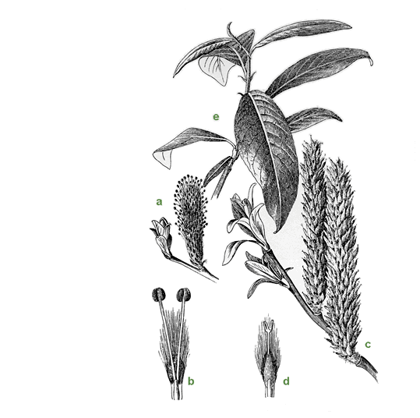](http://www.tinroofalleypoets.org/poetry_boards/index.php?action=dlattach;topic=16899.0;attach=4806;image)

4.   Broom (also laburnum, ulex, Cytisus): Slender green stems, delicate leaves with yellow petals clustered in stubborn bunches, close to the branch. Can often take root in thin soil or white-knuckled in sandy scree. A fire-climax species, it germinates in the seasonal burns even as it unravels in ash.

5.   Ashborn

6.   From meadowsweet, broom, and oak, the magicians Math and Gwyddion formed a bride for Lleu, to lift the tynge laid upon him by his mother, Arianrhod. They called her Bloddieu-wedd, Blossomface.

7.   Columbine in a lime outcropping, caught in a rift in stone. The spur of the petal whirs like a single, tiny sparrow.

8.   “Vast whisp-whisp of wingbeats / minute-long string of black geese”

9.   Adonis mauled by a boar. Aphrodite takes the blood, and from it makes the common poppy.

10.   The Poppy, anemone coronaria: anemone for its wind-bleeding seeds, coronaria for its circlet of blood. Purpura (violet, bright), Purpureus (for its murmuring dress)

11.   Blood and sap, sap and blood

12.   The blood is thin or thick. The blood is blue or red. The child / takes after her mother.

13.   Asphodels: like great white ashes, or ghostflowers laid against tombs. Smoky enough to feed the thin dead with forgetfulness.

[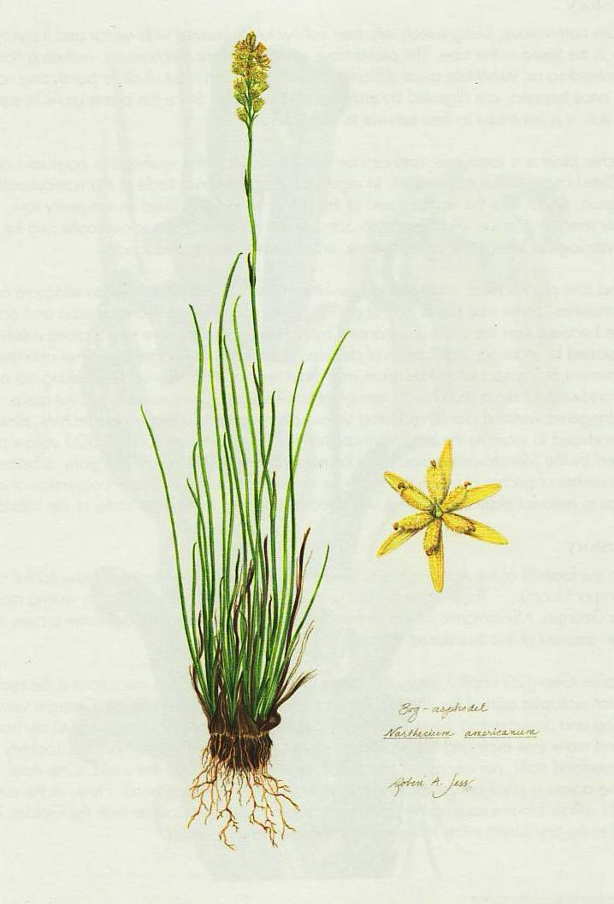](http://www.tinroofalleypoets.org/poetry_boards/index.php?action=dlattach;topic=16899.0;attach=4804;image)

14.   “The beautiful uncut hair of graves”

15.   “skeleton thick sunflower, saw- / dust root, corolla of spikes, seeds / fallen out of its face / dress of dust and soot-blue eyes”

16.   Chrysanthemum psalms

II. Weeds

      i’ve never paid attention to roses,

      or to any other flowers

      but weeds

1.   Clover (seanrog, trifolium cloeferwort): small white, pale pink flowers

2.   Milkthistle: The zebra-stripe yellow of the monarch worm, chewing through w bright precision / the dullcolor leaves. Characterized by popping sap pods and common, purple blossoms.

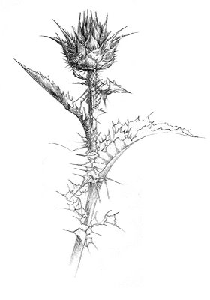

3.   Taraxacum Officinate, ME dent-de-lioun, (lion’s tooth, for its coarsely jagged leaves. Dens leonis, Lowenzahn, dog’s milk, gyermeklancfu (the grass of the child’s / chain), butter blossom.

[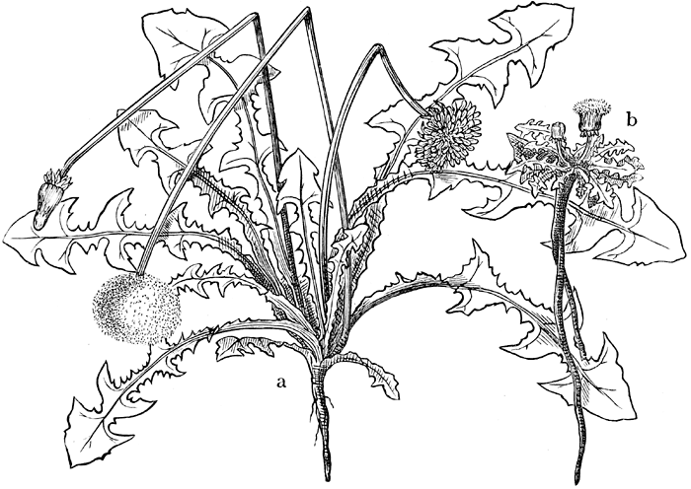](http://www.tinroofalleypoets.org/poetry_boards/index.php?action=dlattach;topic=16899.0;attach=4810;image)

4.   Horse-flower

5.   Ablutions of subtle poisons will protect the lawn, drying up the stalk and blossoms before even the late dry / summer heat can change the upturned cheeks / to the puff-white manes of grandfather stalks.

6.   “This grass is very dark / to be from the white heads of / old mothers,”

“Dark to come from under the faint red roofs of mouths”

“Or I guess the grass is itself a child. . . .”

7.   The Dandelion Flotilla: the needle-like beak lifts a tuft of feathers, the pappus carrying fruit, above the dangling Achene sheathed in spines.

8.   The flowerhead: A ribbon-like corolla of petals, golden. Inside, the stigma catches seed above a cylinder of woven anthers. The hollow stem supports the fragrant flowerhead, and bitter white juice runs through the rosette circumference of fingers.

9.   The taproot, sinking deep

      we bound them up in chains

      twisted split stems in a helix

      pattern, wending down through

      tawny braids, a garland of golden

weeds

## hush, dear hands

*i.*

dried petals of dusk.

the husk of yr dress.

an echo.

*ii.*

hiding from me

behind figs: your blue eyes

can't cover the liquid-

dark sleep.

*iii.*

hush, dear hands--this song is enough.

*iv.*

lovewords.

father teach me.

## Sappho 24

Remember:

we too did the same

in our youth.

we are many

and lovely in the city,

in the city’s foundations we live

at a whisper

*ii. Sappho 88*There’s little you could  
wish for  
sweeter:

Some might say  
you’ve forgotten, but I  
will love  
as long  
as I  
have breath.  
  
I have been  
a friend  
to you.

sweet and  
bitter, yes.  
but know that I  
will love you.